- Given the following confusion matrix from a spam filter (Actual: Spam=70, Not Spam=130; Predicted: Spam=60, Not Spam=140; TP=50, TN=120, FP=10, FN=20), manually calculate the values of accuracy, precision, recall, and F1 score on paper or in a Jupyter notebook.

1. Spam Filter Manual Calculations
Given: $\text{TP}=50$, $\text{TN}=120$, $\text{FP}=10$, $\text{FN}=20$, and $\text{Total}=50+120+10+20=200$.
- Accuracy: $\frac{\text{TP}+\text{TN}}{\text{Total}}=\frac{50+120}{200}=\frac{170}{200}=85.00\%$
- Precision: $\frac{\text{TP}}{\text{TP}+\text{FP}}=\frac{50}{50+10}=\frac{50}{60}=83.33\%$
- Recall: $\frac{\text{TP}}{\text{TP}+\text{FN}}=\frac{50}{50+20}=\frac{50}{70}=71.43\%$
- F1 Score: $2×\frac{\text{Precision}×\text{Recall}}{\text{Precision}+\text{Recall}}=2×\frac{0.8333×0.7143}{0.8333+0.7143}=76.92\%$

===========================================================================

- Write a Python function called print_confusion_matrix(tp, tn, fp, fn) that prints the confusion matrix in a readable table format for any given values of true positives, true negatives, false positives, and false negatives.

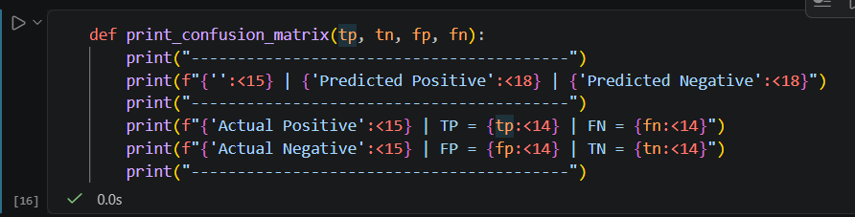

===========================================================================
- Imagine you are evaluating a fake news detection model for a social media app. The model flagged 80 posts as fake, of which 60 were actually fake (TP), and missed 30 fake posts (FN). There were 120 posts correctly identified as not fake (TN), and 10 real posts wrongly flagged as fake (FP). Calculate and print the precision and recall for this model. Precision = TP / (TP + FP), Recall = TP / (TP + FN)

Fake News Detection Model Evaluation
Given: $\text{TP}=60$, $\text{FP}=10$, $\text{FN}=30$, $\text{TN}=120$.
- Precision:
$$\text{Precision}=\frac{60}{60+10}=\frac{60}{70}≈85.71\%$$
(Out of all posts flagged as fake, 85.71% were actually fake).
- Recall:
$$\text{Recall}=\frac{60}{60+30}=\frac{60}{90}≈66.67\%$$
(Out of all actual fake posts, the model successfully caught 66.67%).

===========================================================================

- Given a confusion matrix for a food delivery fraud detection system (TP=40, TN=150, FP=20, FN=10), write Python code to compute the F1 score and explain in one line what the F1 score tells you about the model's performance. F1 = 2 * (precision * recall) / (precision + recall)

